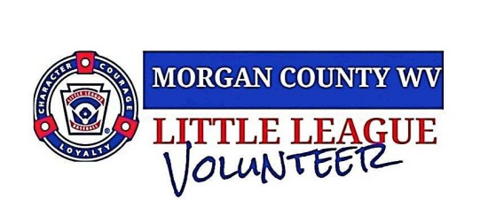
Want to become a volunteer with MCLL and make a difference in your community? Make sure you fill out the volunteer background check application and attach it to this form!
As a nonprofit organization, we run on amazing support from all our volunteers. You’re what helps keep us going to inspire and encourage all our talented players. Volunteers support MCLL to be more organized towards raising money in concessions, applying fundraisers for supplies, equipment, gear and even being able to host family events such as closing ceremonies and tournaments.
So we invite you to follow us on Facebook- www.facebook.com/WVMCLL and on our website- https://tshq.bluesombrero.com/mcllwv so you can always stay in touch with upcoming events, fundraisers, photos, updates and more!
- Parent Name (Print) _______________________________________
- Player’s Name (Print)______________________________________
- Best way to contact you (Circle and establish info) Email / Text / Call ________________________________________________________
- Would like to volunteer for: (Circle as many as desired)
  - Concession Helper
  - Field Maintenance Helper
  - Umpire
  - Coach
  - Manager
  - Other__________________________
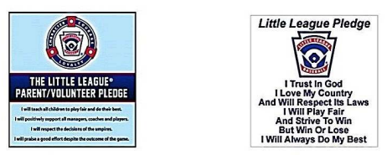

**REMINDER: DON’T FORGET TO ESTABLISH EMAIL, SS#, DOB AND SIGN!!**
